**Chennai Zone**

1. **GST Doctor Software** (Developed by our officer)

In order to ease the verification of the monthly GST returns, a software/ web-application viz *“GST Doctor Software”* was developed by one of the officers of Chennai Zone. The main areas of verification of GST returns by field officers are scrutiny of returns (GSTR 1 vs GSTR 3B vs GSTR 2A) and validation of ITC availed in GSTR-3B using Invoice wise ITC matching.

The software is successfully tested by officers of the field formations of Chennai Zone for following applications:-

1. GST Audit for one or more years by Audit Commissionerates.
2. Processing of Refund (Matching of Invoices in Annexure B with GSTR-2A) by Executive Commissionerates.
3. Scrutiny of Returns by Executive Commissionerates.

**Features-**

* GSTR-1 Consolidation and detection of invoices shown in wrong month for demanding interest.
* GSTR-2A Consolidation and detection of invoices by taxpayers who filed GSTR-1 but not filed GSTR-3B.
* GSTR-3B Consolidation and auto-calculation of interest based on extended due dates.
* Returns Scrutiny (GSTR-1 vs GSTR-3B vs GSTR-2A vs GSTR-9).
* Advanced invoice-wise ITC Matching for GST Audit and Refund processing.
* Web tools for checking Blocked and Common ITC for reversal at <https://gstdoctor.in/tools>.

**Sample Screenshot-**

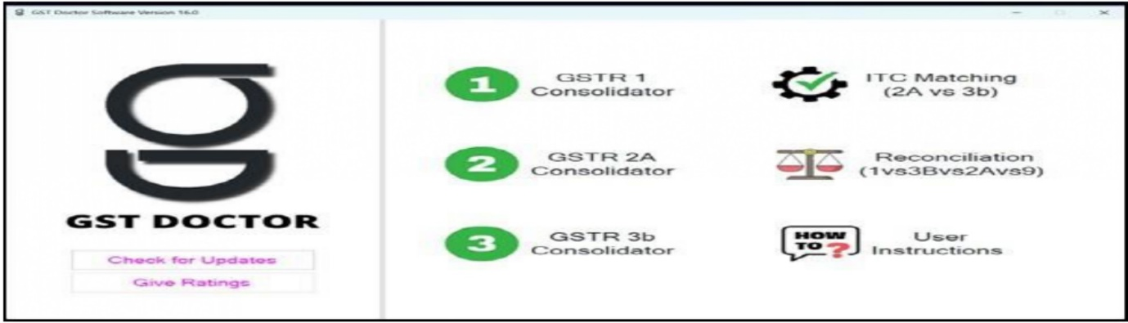

A copy of the D.O letter addressed in the past, along with the enclosures is attached herewith for ready reference.

1. **Netrikann – The Third Eye** (Developed by our officer)

A web platform named as “Netrikann” (Tamil word: meaning 3rd Eye) was developed to provide access to the data regarding the defaulters of Returns, which will be useful for pursuing/nudging the return compliance; for monitoring the same by superior officers etc.

**Features-**

* GST Return non-filers dashboard for top taxpayers-
* Each month return filing status starting from Apr-2022 updated daily.
* Taxpayers categorized based on tax paid in last financial year.
* List of taxpayers not–filing returns for more than 3/6 months.
* Reports available from Zone up to Range level.
* Risky refunds scores based on 12 parameters up to range level updated daily.

**Sample Screenshot-**

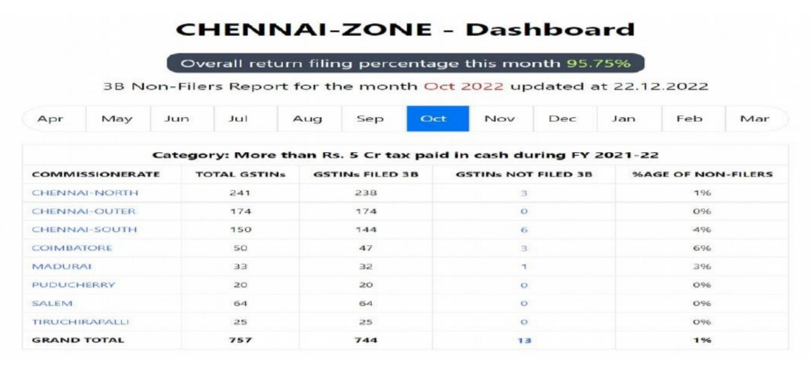

A copy of the D.O letter dtd: 21.12.2022 addressed to the Chairman CBIC in the past, along with it’s enclosures is attached herewith for ready reference.

1. **MSME - Trade Facilitation Committee (MSME-TFC) :-**

* MSME - Trade Facilitation Committee (MSME-TFC) were formed with an objective of providing continuous handholding for empowering MSMEs for voluntary compliance to GST law and reduce their cost of compliance.
* MSME-TFC was formed in all the Eight Executive Commissionerates under this Zone in the State of Tamil Nadu and Pondicherry, consisting of Members from the Government Department and representatives of the MSMEs from various sectors like Textile, Steel, Plastic, Chemical, Pharmaceutical, Machinery etc.
* Trade Notices have been issued by the respective Jurisdictional Commissionerate and the same are displayed in the Zonal website.
* This system of regular handholding process through Monthly Open House Trade Facilitation Committee Meetings are held exclusively for MSME sector by the Commissionerates, where operational issues, policy related issues and system related issues are discussed and the same are examined for further necessary action.
* Schedule of the monthly meetings are decided well in advance for the entire financial year and communicated to the members, so that they can plan their schedule accordingly to attend the meeting.
* Issues for discussion are being requested to be submitted adequately in advance, so that the points / issues can be resolved/guided, then and there during the meeting.
* Minutes of the meetings are communicated for the benefit of all stakeholders and the field officers.
* There has been a very good response for this trade facilitation measure.

A copy of the D.O letter dtd: 18.10.2022 addressed to the Chairman CBIC in the past, along with it’s enclosures is attached herewith for ready reference.

1. **Providing of SIM and mobile with Whats app facility to all the field formations**

* Mobile SIMS & equipment were provided to all Ranges, Divisions and selected sections of the Commissionerates, in this Zone - in order to ensure better communication network for; quick dissemination of the information and to ensure immediate response for any issues/grievances etc.; and also to ensure that the contact numbers remain the same for the respective offices, irrespective of the transfers/retirements etc. of the officers. It also ensured effective use of the Mobile phones for receiving OTP for access to various platforms like LIMBS/DIGIT; and also helps in officially capturing the location of the premises during physical verifications of the new registrants.
* A total of 670 SIMs along with mobiles [with Whats app facility], were provided to all the Ranges/Divisions/Commissionerates, together. The said permanent contact details of the formations are communicated to the stakeholders for ease of access.
* This facility helps the taxpayers to share their queries on Whats app and by contacting the jurisdictional officers over phone with 24 x 7 facility.
* This unique system resulted in various queries of the taxpayers getting addressed and resolved promptly.

1. **Central Data Analytics Centre ( DAC) :**

* A central Data Analytics Centre was set up at Pr. CCO during 08/2022 with adequate officers, in the grade of Supdts. & Inspectors, with sound knowledge in IT and with experience in Analytics, headed a by a Dy. Commissioner with similar background.
* They were trained to use the data analytics tools like BIFA and use the Data on ADVAIT/EWB portal etc.
* During the past 7 months DAC developed 206 Intelligences and shared them with the field formations for action.
* So far, the field formations, based on about 65 No. of DAC-intelligences, had detected evasion of Rs.1711 Cr. and recovered Rs.400 Cr.

The intelligences developed by the DAC are found to be very reliable and are yielding commendable results, as the intelligences were purely based on the data analysis.

1. **WhatsApp group with Trade:**

* A WhatsApp group was formed by the officers of the Zone with Confederation of Indian Industry, various other Trade Associations, members of MSME of Tamil Nadu and Puducherry and individual taxpayers.
* It is a trade facilitation measure for
* discussion of queries raised by the members.
* providing important updates on GST,
* tweets in English and vernacular language on various obligations of taxpayers like last dates of filing various returns to prompt the taxpayers to file returns in time etc.
* This would result in healthy interaction and be beneficial to all stakeholders in the group.
* There has been a very good response for this trade facilitation measure